**Use Case Diagram**

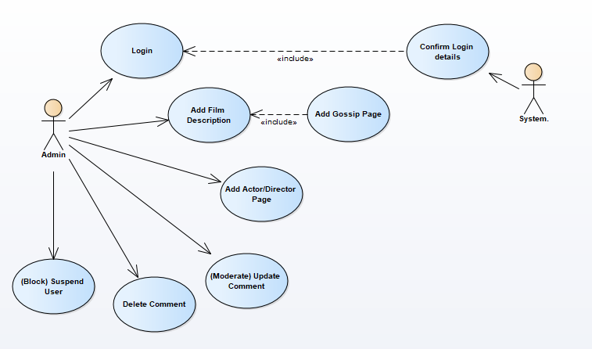

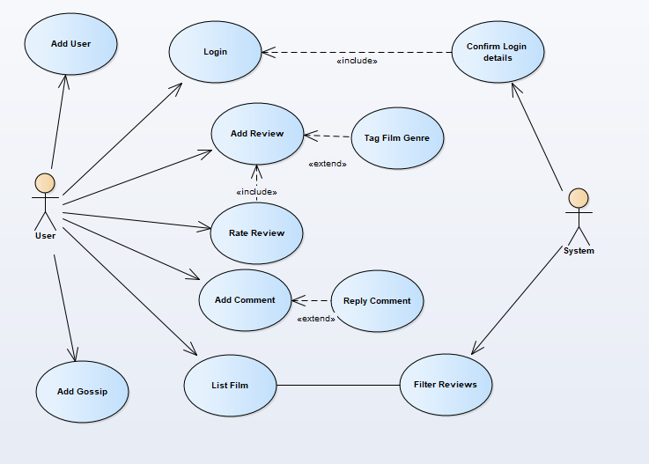

Simple update – no ‘System 2’

**Class diagram**

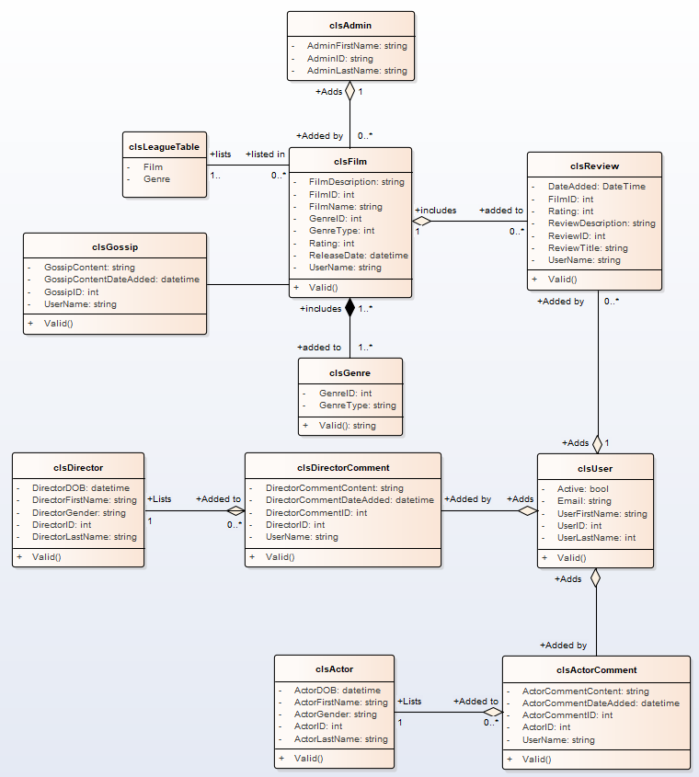

**added gossip class and Valid method**